240701020 - ADITYA S

EXPERIMENT – 03

SURVEY REPORT ON EMERGING TRENDS IN LOW-CODE APPLICATION DEVELOPMENT
- AIM
To design and build a functional "Vehicle Service Request Form" application using Zoho Creator as a low-code development platform, demonstrating the use of its Basic Fields to collect and organize vehicle service and repair requests.

Traditional application development vs emerging trends in low-code application development
Traditional application development generally requires developers to write and maintain code for the user interface, business logic, database operations, validation, integrations and deployment. For a vehicle service center, a conventional system would normally require separate development of the customer registration interface, service-request database, validation logic, reporting and notification features.
Low-code application development uses visual form builders, pre-built fields, reusable components, workflow configuration and ready-made integrations. In this experiment, Zoho Creator is used to build the Vehicle Service & Repair Request Management application. The application uses a single Service_Request_Form to capture owner identity, contact information, vehicle details, issue description, preferred service schedule and authorization. A Service_Request_Report is used to manage submitted requests.

Aspect | Traditional Application Development | Emerging Low-Code Development
Development | Manual programming using programming languages, frameworks and libraries. | Visual form builders, drag-and-drop components and configuration.
Development Time | Usually requires more time to develop individual screens, validations and workflows. | Faster development for many business applications using reusable components.
Technical Skill | Requires programming and software development knowledge. | Reduces the amount of coding required and can support developers and technically skilled users.
Forms and Fields | Fields and validation logic are normally coded or configured manually. | Pre-built fields such as Name, Email, Address, Phone, Number, Date, Time and selection fields are available.
Workflow | Business workflows are generally implemented through custom code or separate automation tools. | Workflow actions can be configured visually within the platform.
Reports | Reports and filtering normally require application and database development. | Report views can be generated from submitted form records.
Integration | APIs and integration logic may need to be implemented manually. | Platforms commonly provide built-in connectors and integration capabilities.
Customization | Offers extensive control over architecture and application behaviour. | Provides rapid development within the capabilities and limitations of the platform.

Benefits and Challenges in Low Code.

Benefits:
  - Faster development of forms and business applications through visual development tools.
  - Reduced repetitive coding because common field types, validations and components are already available. Easy creation of structured forms for collecting customer and service information.
  - Workflow automation can reduce manual work such as acknowledgements and record processing. Reports can

organize submitted records so that service-center staff can filter and manage requests. Rapid modification of fields and application structure when business requirements change.
  - Useful for small and medium business applications such as service requests, registration systems and workflow-based applications.

Challenges:
  - Dependence on the selected low-code platform and its available features.
  - Highly specialized requirements may still require custom code or additional development. Security and privacy settings must be configured correctly when handling customer information. Performance and scalability need to be considered as the number of users and records increases.
  - Migration from one low-code platform to another may require redesign because platform structures differ.
Licensing,

subscription and premium integration costs may affect the overall cost of the solution.

  - Governance is important when multiple users create and modify applications on the same platform.

Comparison of existing platforms (tabulation)
The following table compares commonly used low-code platforms that can be used to develop forms, workflows and business applications similar to the vehicle service request use case.

Platform | Provider | Primary Focus | Key Features | Automation / Integration | Example Use
Zoho Creator | Zoho | Business applications | Forms, reports, dashboards,  workflows and visual app  building | Strong | Vehicle service requests,  business forms and  workflow applications
Microsoft Power Apps | Microsoft | Business and enterprise apps | Canvas apps, model-driven  apps, connectors and  Dataverse | Strong | Enterprise forms, approvals  and internal applications
OutSystems | OutSystems | Enterprise applications | Visual development,  web/mobile applications and  integrations | Strong | Enterprise web and mobile  systems
Mendix | Siemens | Enterprise low-code  development | Visual modeling,  integrations, collaboration  and deployment tools | Strong | Enterprise application  development
No-code app creation, data

connections and automation

AppSheet | Google | Data-driven applications |  | Strong | Operational and data-based  applications
Salesforce Platform | Salesforce | CRM and business  applications | Data model, workflows,  application development and  integrations | Strong | CRM and enterprise  business applications

Vehicle Service Request Form – Zoho Creator Screenshots

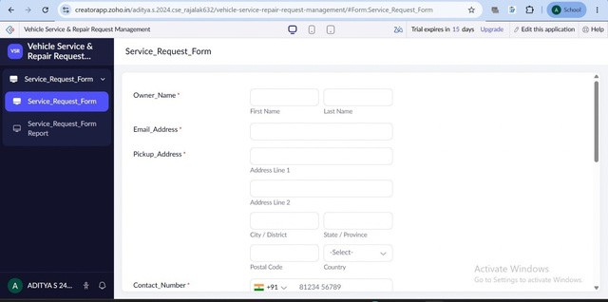

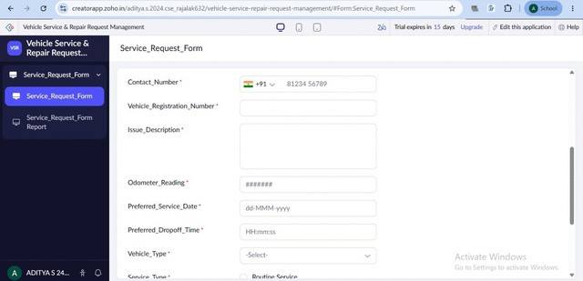

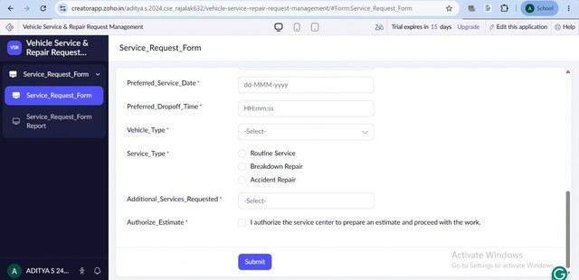

Result
The Vehicle Service & Repair Request Management application was designed using Zoho Creator as a low-code development platform. The application demonstrates how visual form building, predefined Basic Fields, validation, report management and workflow concepts can be used to collect vehicle service requests. The comparison with traditional development and other low-code platforms shows how low-code approaches can reduce repetitive development effort while still requiring attention to customization, security, governance, scalability and platform dependency.

